Tutorial for user

There are two modes to use this software: InputRun and ExcelRun. We recommend you to use ExcelRun mode.

About InputRun:

1. Open “ML Prediction Model.exe” in ML Prediction Model folder
2. Select InputRun
3. Input patients data
4. Press Run and wait 10-60 seconds

This mode only allows you to get one result at a time.

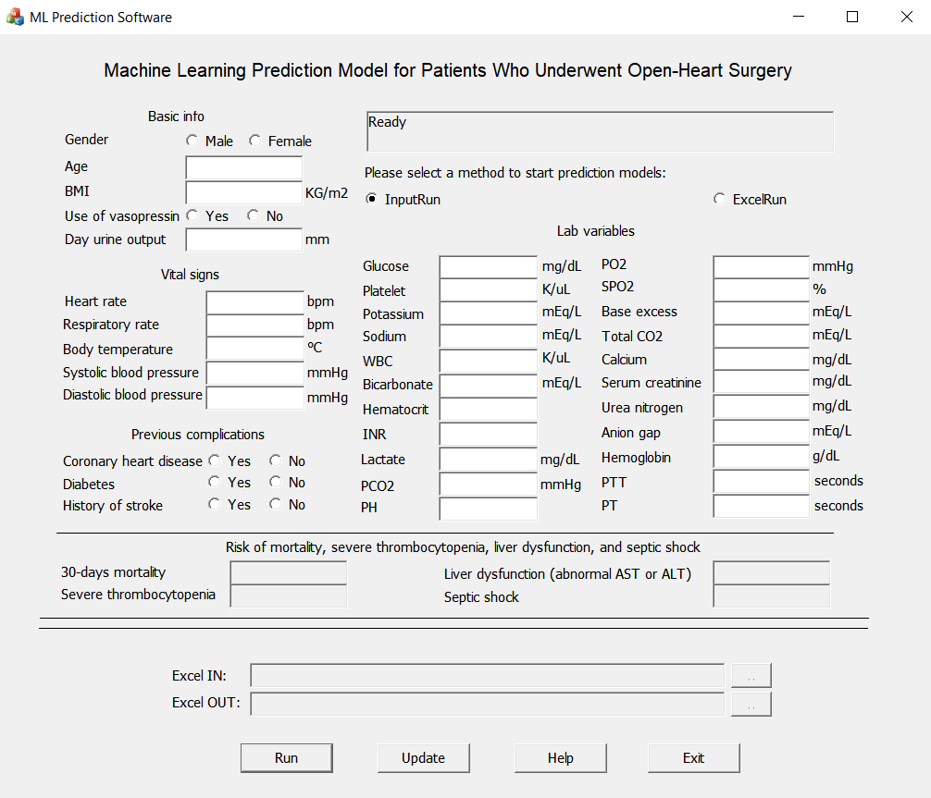

About ExcelRun:

1. Open “ML Prediction Model.exe” in ML Prediction Model folder
2. Select ExcelRun
3. Open “example.xlsx” in ML Prediction Model folder
4. Input patients data into excel, make sure that each row represent a patient and then fill in the data according to the column name (like the picture below)
5. Select your input file path and output file path (input excel file path and output excel path)
6. Press Run and wait 10-60 seconds
7. Obtain your output file in the output file path. The risk of mortality and 3 complications will be added to the four rightmost columns in the excel sheet.

You can process many data easily by using this mode. But please make sure to keep the format exactly the same as "example.xlsx" file! (the format of rows and columns)

